**PROPOSED SOLUTION**

**NOVELTY:**

**\*Nowadays new dietary assessment and nutrition analysis tools enable more**

**Opportunities to help people understand their daily eating habits, exploring**

**Nutrition patterns and maintain healthy diet.**

**\*Nutrition analysis is the process of determining the nutritional content of food it is a vital part of analytical chemistry that provide composition processing, quantity control and contamination of food.**

**\* A diet is all that we consume in a day. And a balanced diet is a diet that contains an adequate quantity of the nutrients that we require in a day. A balanced diet includes six main nutrients, example Fats, Protein, Carbohydrates, Vitamins, and Minerals.**

**\* Good nutrition throughout life is essential to good health. Eating a healthy diet can help reduce the risk of obesity, coronary heart disease, stroke, some cancers, type 2 diabetes, high blood pressure, osteoporosis and tooth decay.**

**BUSINESS MODEL**

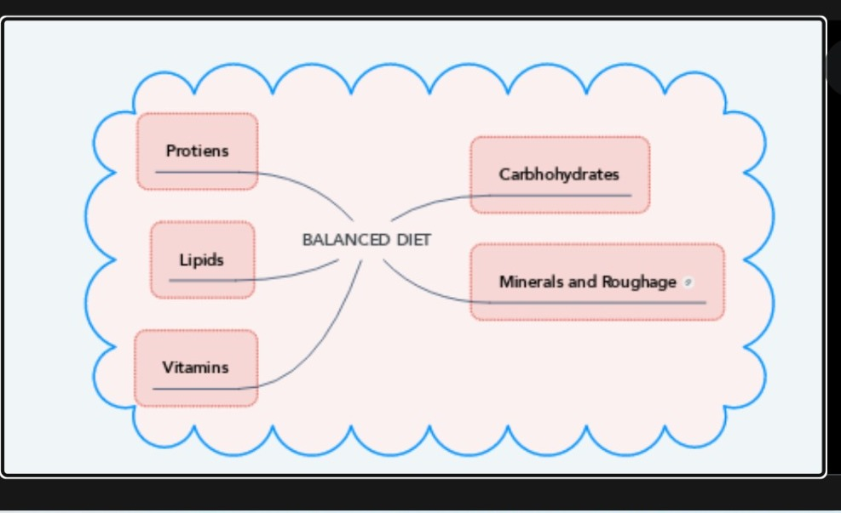

**SOCIAL IMPACT:**

**\*The relationship between an individual's social, psychological, and cultural environment and his or her nutritional status is one of both cause and effect. Cultural patterns, economic stability, and attitudes toward health and disease all affect an individual's eating behavior.**

**\*Healthy diet helps children grow and develop properly and reduces their risk of chronic diseases. Adults who eat a healthy diet live longer and have a lower risk of obesity, heart disease, type 2 diabetes, and certain cancers.**

**\*Healthy diet is one way you can improve your mental health. Other things include staying physically active, spending time in nature, avoiding cigarettes and alcohol and developing good sleep habits.**

**\* It can also improve concentration and attention span. Conversely, an inadequate diet can lead to fatigue, impaired decision-making, and can slow down reaction time. In fact, a poor diet can actually aggravate, and may even lead to, stress and depression.**

**\*Additionally, while harmful societal norms are only one of many factors that lead to the development of mental health conditions and eating disorders, diet culture influences rising rates of anorexia, bulimia, binge eating disorder, and avoidant/restrictive food intake disorder**

**FEASIBILITY OF IDEA:**

**\*Artificial intelligence has the potential to transform us food system by targeting its biggest challenges improving food yield, quantity and nutrition decreases resource consumption increasing safety and traceability and eliminating food waste.**

**\*Despite big leaps in AI capacity food system present several challenges**

**For the application and adoption of AI.**

* **Food system are highly diverse and biologically complex**
* **Ground truth data is sparse costly and privately held**
* **Human decision and preference are intricately linked to every stage of food system chain.**

**\*AIFS is developing generalized data efficient and trustworthy AI solutions of based learning paradigm designed to handle food system diversity and biological complexity, efficiently capture and utilize data, and user trust via safety privacy.**

**SCALABILITY OF SOLUTION:**

**\*Try to make at least half (or preferably all) your daily grains whole grains. Foods made from whole grains are a major source of energy and fiber. Learn to read food labels so you can identify which grains are truly whole grains.**

**\*Enjoy your food but eat less. Take time to fully enjoy what you are eating. This is called mindful eating. Eating quickly or not paying attention to what you eat, known as mindless eating, can lead to eating too many calories.**

**\*Healthy diet is essential for good health and nutrition. It protects you against many chronic noncommunicable diseases, such as heart disease, diabetes and cancer. Eating a variety of foods and consuming less salt, sugars and saturated and industrially-produced trans-fats, are essential for healthy diet.**